**A Multi-Container App with Kubernetes**

* **The Path to Production:**

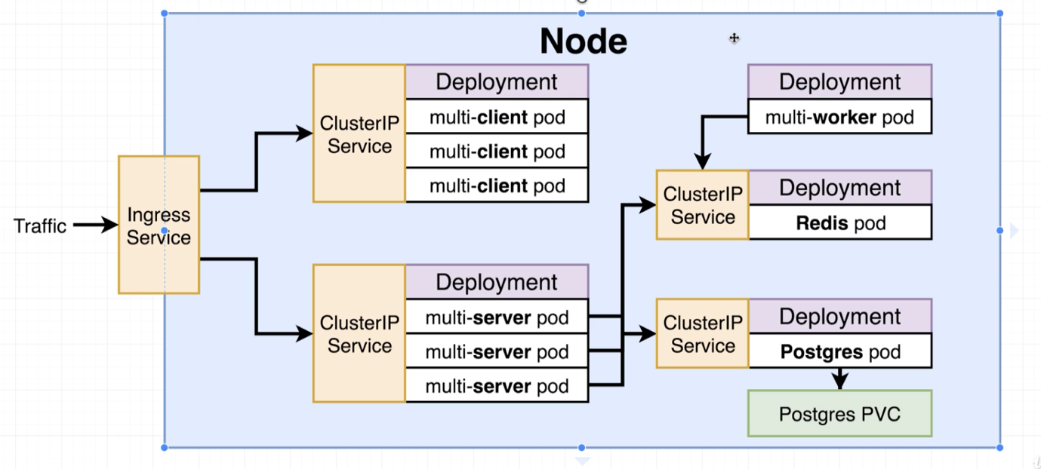

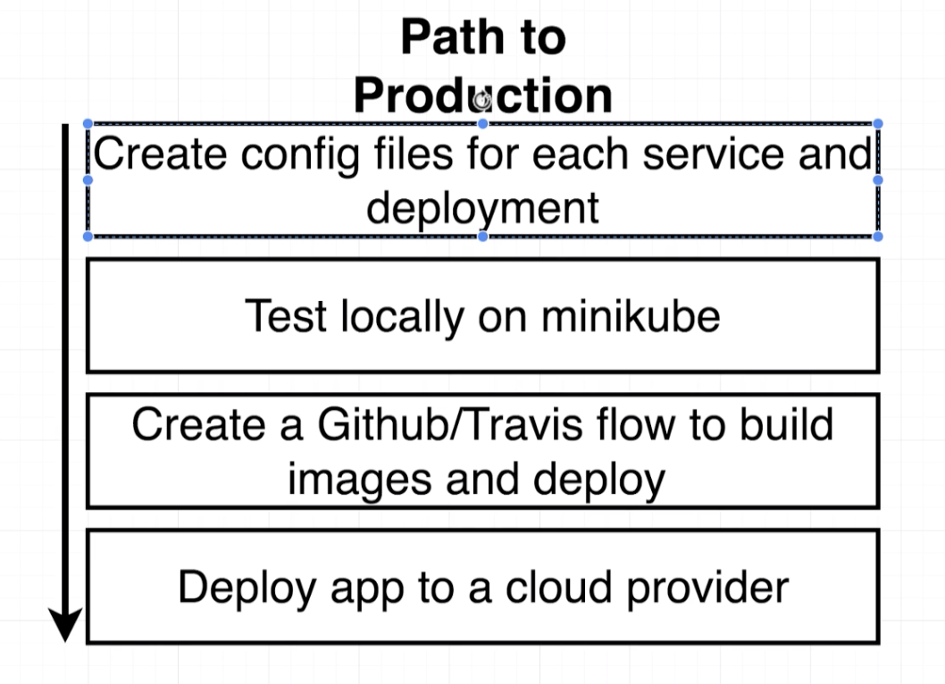

* **A Quick Checkpoint:**
* **Recreating the Deployment:**

apiVersion: apps/v1

kind: Deployment

metadata:

name: client-deployment

spec:

replicas: 3

selector:

matchLabels:

component: web

template:

metadata:

label:

component: web

spec:

containers:

- name: client

image: stephengrider/multi-client

ports:

- containerPort: 3000

* **NodePort vs ClusterIP Services:**

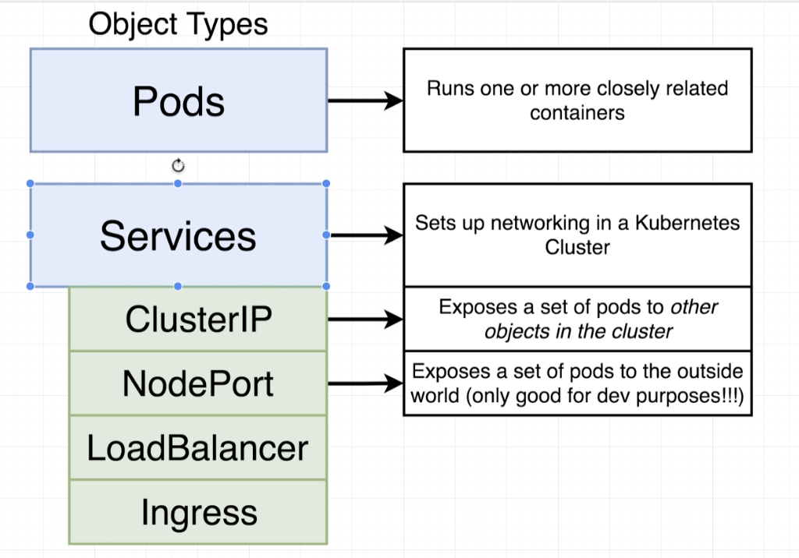

* **The ClusterIP Config:**

apiVersion: v1

kind: Service

metadata:

name: client-cluster-ip-service

spec:

type: ClusterIP

selector:

component: web

ports:

- port: 3000

targetPort: 3000

* **Applying Multiple Files with Kubectl:**

Delete the deployments using below command.

kubectl delete deployment client-deployment.

Delete the services using below command.

kubectl delete service client-node-port

We can apply all the files using below command.

kubectl apply -f folder_name

kubectl apply -f k8s

* **Express API Deployment Config:**

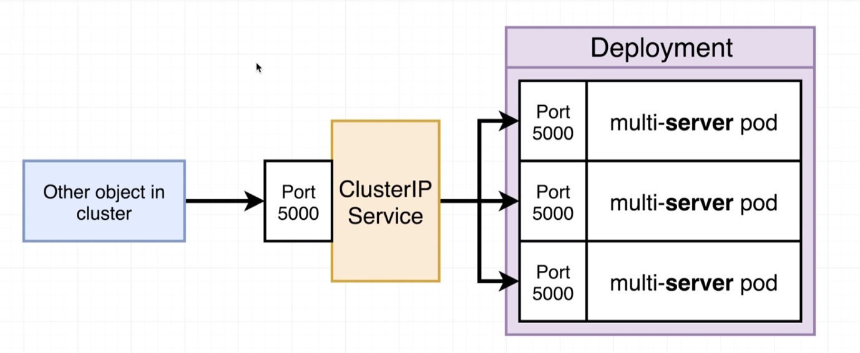

apiVersion: app/v1

kind: Deployment

metadata:

name: server-deployment

spec:

replicas: 3

selector:

matchLabels:

component: server

template:

metadata:

labels:

component: server

spec:

containers:

- name: server

image: stephengrider/multi-server

ports:

- containerPort: 5000

* **Cluster IP for the Express API:**

apiVersion: v1

kind: Service

metadata:

name: server-cluster-ip-service

spec:

type: ClusterIP

selector:

component: server

ports:

- port: 5000

targetPort: 5000

* **Combining Config into Single Files:**

Instead of writing configuration for a single component into multiple files, we can use a single file to write all the configurations.

Create a file name of your choice. Ex – server-config.yaml and add the configurations as shown below.

apiVersion: app/v1

kind: Deployment

metadata:

name: server-deployment

spec:

replicas: 3

selector:

matchLabels:

component: server

template:

metadata:

labels:

component: server

spec:

containers:

- name: server

image: stephengrider/multi-server

ports:

- containerPort: 5000

---

apiVersion: v1

kind: Service

metadata:

name: server-cluster-ip-service

spec:

type: ClusterIP

selector:

component: server

ports:

- port: 5000

targetPort: 5000

* **The Worker Deployment:**

apiVersion: apps/v1

kind: Deployment

metadata:

name: worker-deployment

spec:

replicas: 1

selector:

matchLabels:

component: worker

template:

metadata:

labels:

component: worker

spec:

containers:

- name: worker

image: stephengrider/multi-worker

* **Reapplying a Batch of Config Files**

kubectl apply -f k8s

kubectl get pods

kubectl logs pod_id

> @ start /app

> node index.js

Listening

{ Error: connect ECONNREFUSED 127.0.0.1:5432

at TCPConnectWrap.afterConnect [as oncomplete] (net.js:1161:14)

errno: 'ECONNREFUSED',

code: 'ECONNREFUSED',

syscall: 'connect',

address: '127.0.0.1',

port: 5432 }

* **Creating and Applying Redis Config:**

apiVersion: apps/v1

kind: Deployment

metadata:

name: redis-deployment

spec:

replicas: 1

selector:

matchLabels:

component: redis

template:

metadata:

labels:

component: redis

spec:

containers:

- name: redis

image: redis

ports:

- containerPort: 6379

apiVersion: v1

kind: Service

metadata:

name: redis-cluster-ip-service

spec:

type: ClusterIP

selector:

component: redis

ports:

- port: 6379

targetPort: 6379

* **Last Set of Boring Config:**

apiVersion: apps/v1

kind: Deployment

metadata:

name: postgres-deployment

spec:

replicas: 1

selector:

matchLabels:

component: postgres

template:

metadata:

labels:

component: postgres

spec:

containers:

- name: postgres

image: postgres

ports:

- containerPort: 5432

apiVersion: v1

kind: Service

metadata:

name: postgres-cluster-ip-service

spec:

type: ClusterIP

selector:

component: postgres

ports:

- port: 5432

targetPort: 5432

* **The Need for Volumes with Databases:**

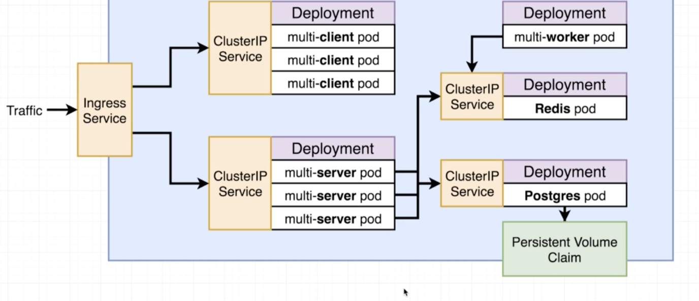

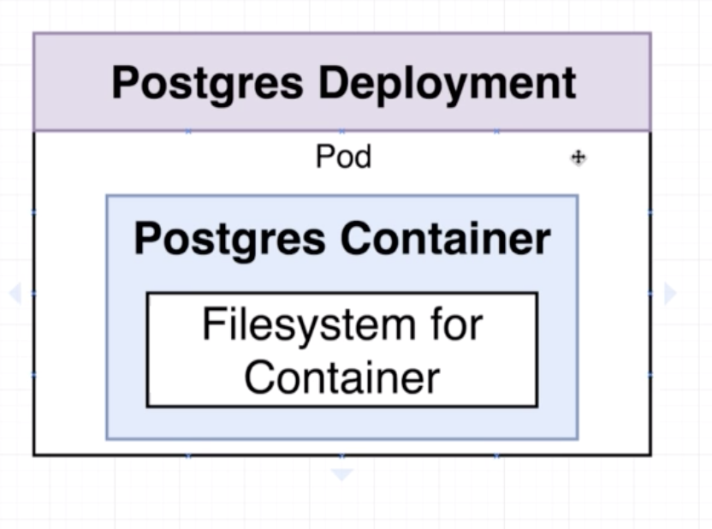

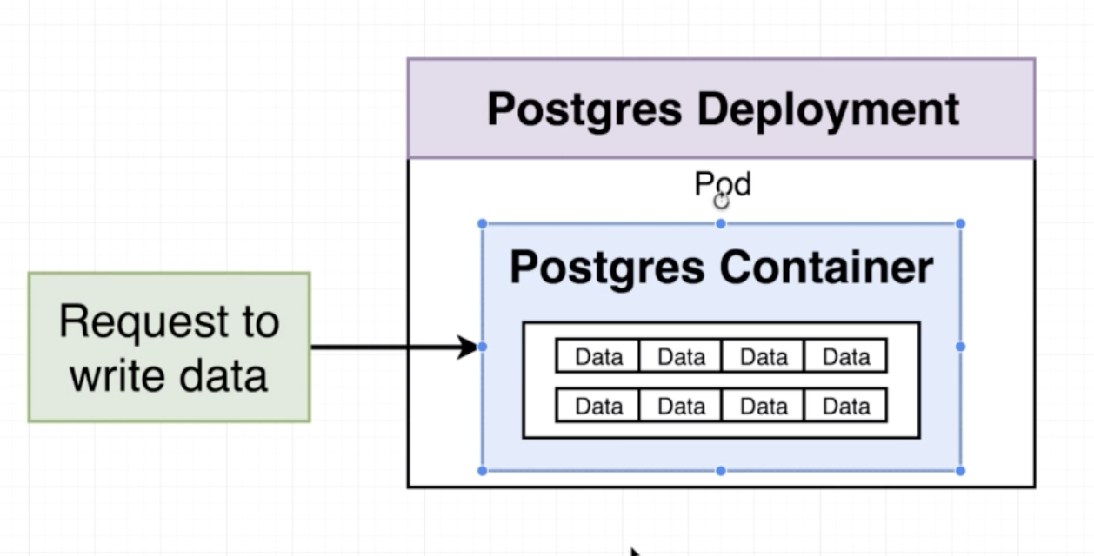

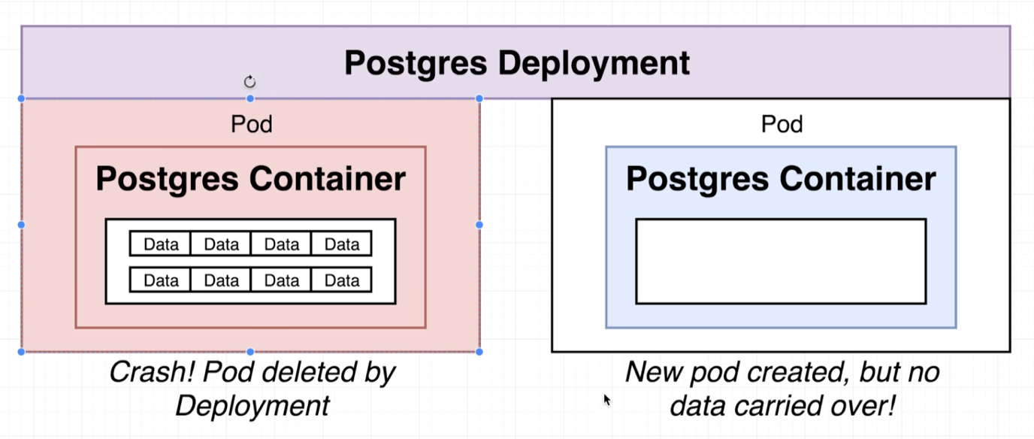

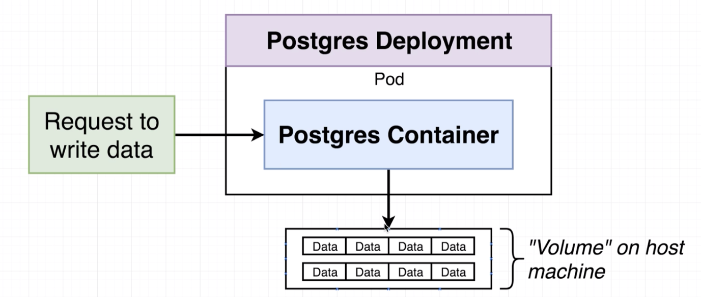

* **Kubernetes Volumes:**

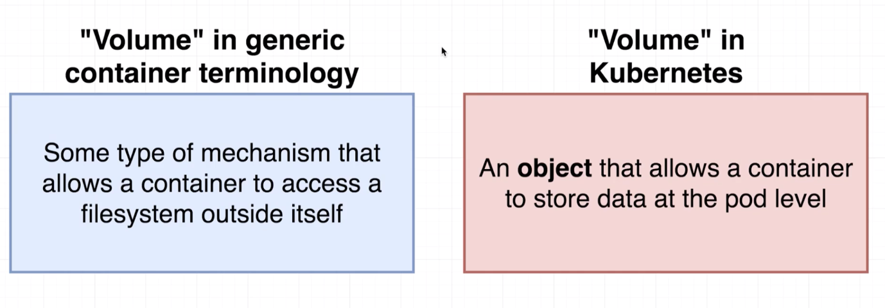

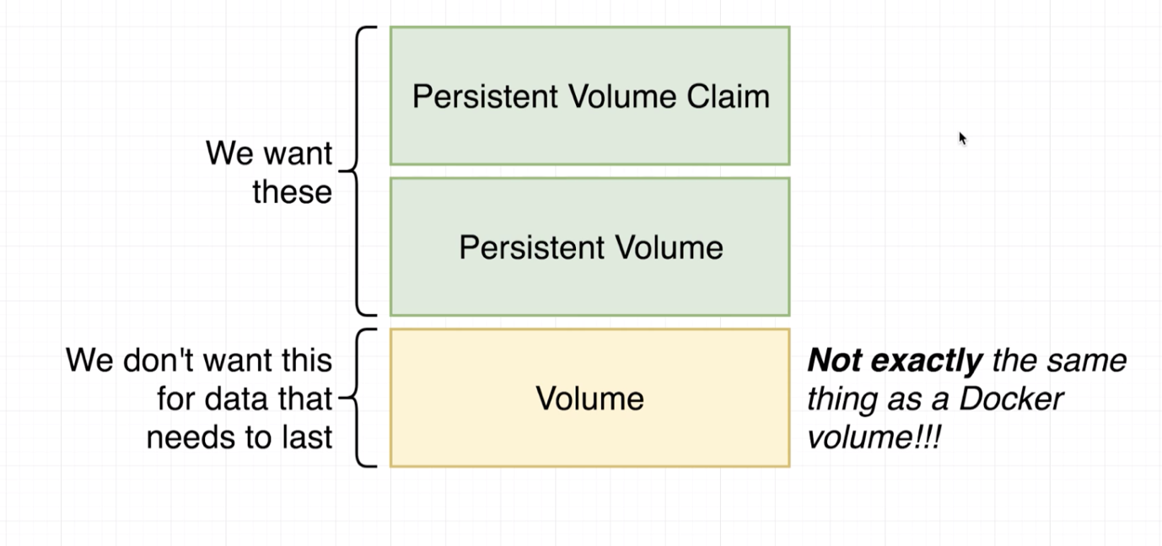

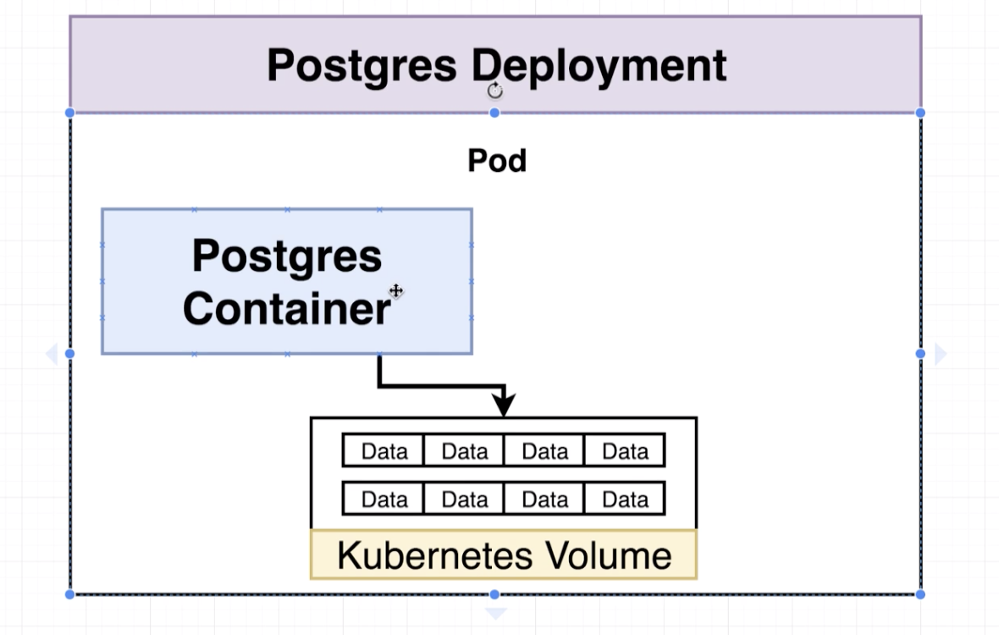

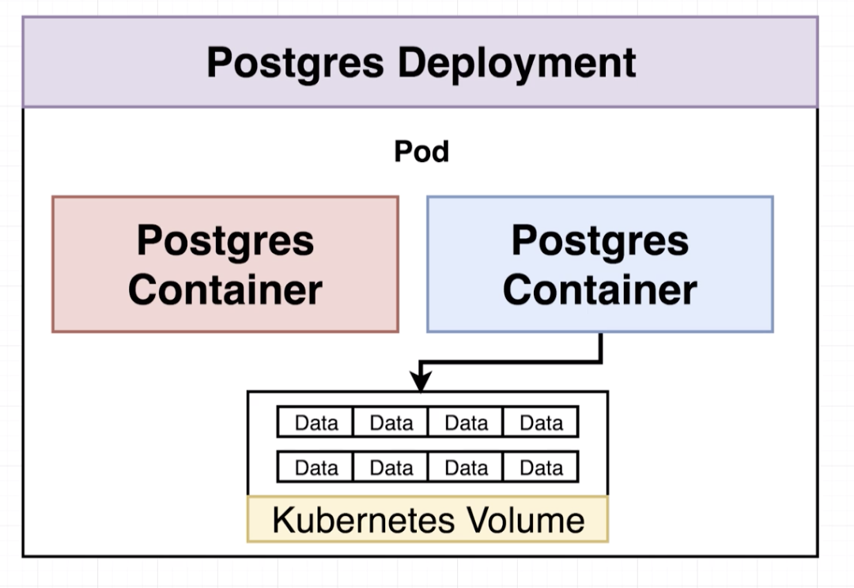

**Note:** In Kubernetes Volume is an object which allows pods to save something to the file system. Volume is associated with pod, so whenever a Pod goes down, even the associated Volume also goes down.

* **Volumes vs Persistence Volumes:**

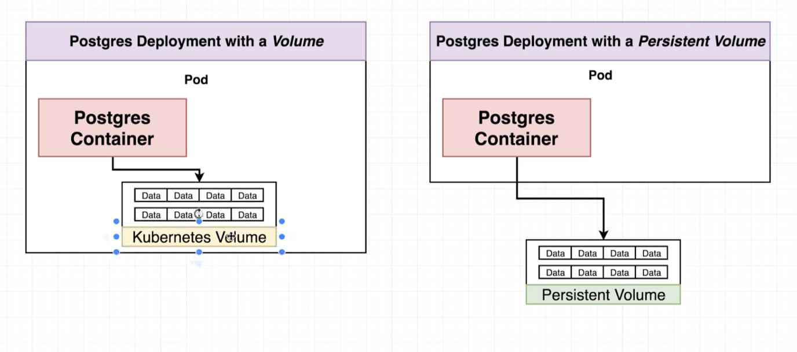

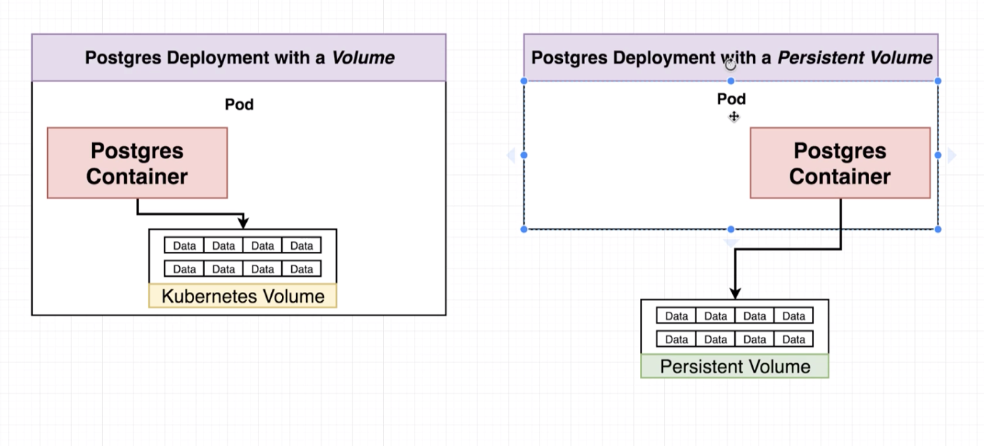

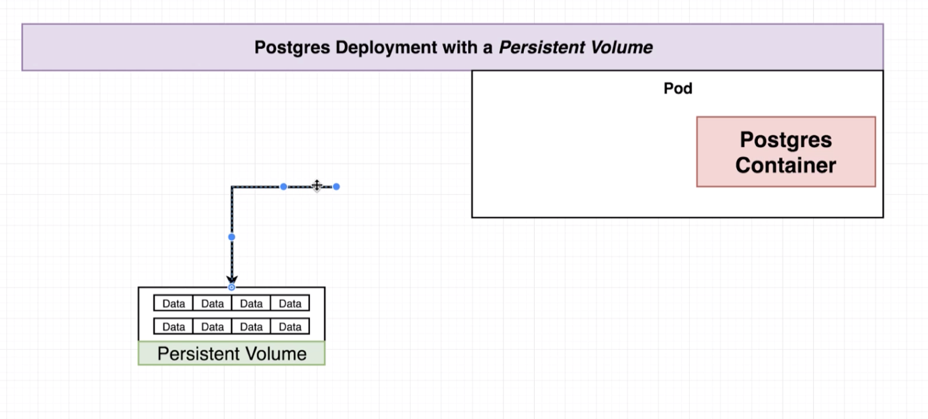

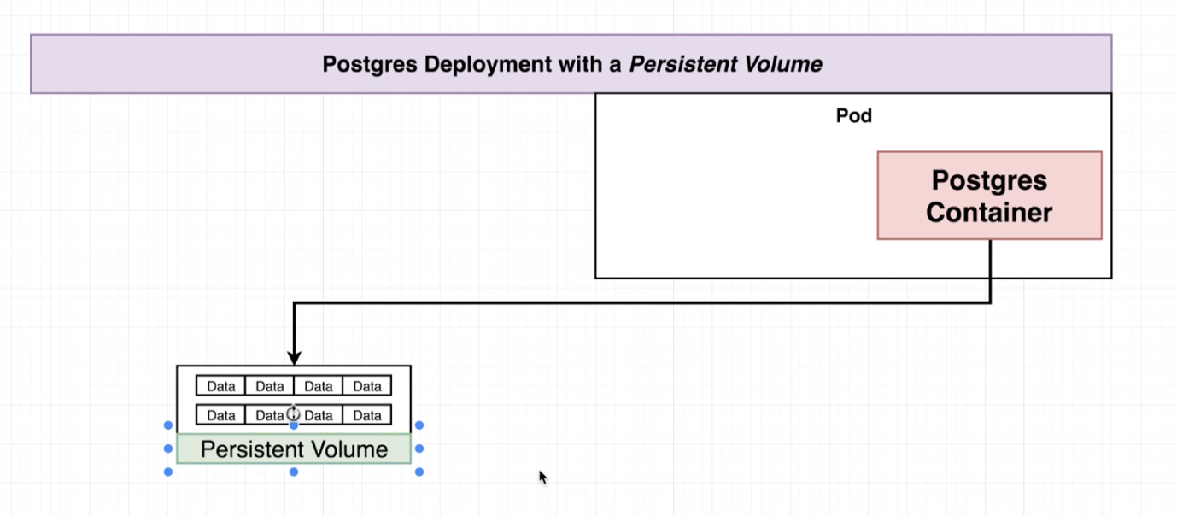

* **Persistent Volumes vs Persistent Volume Claims:**

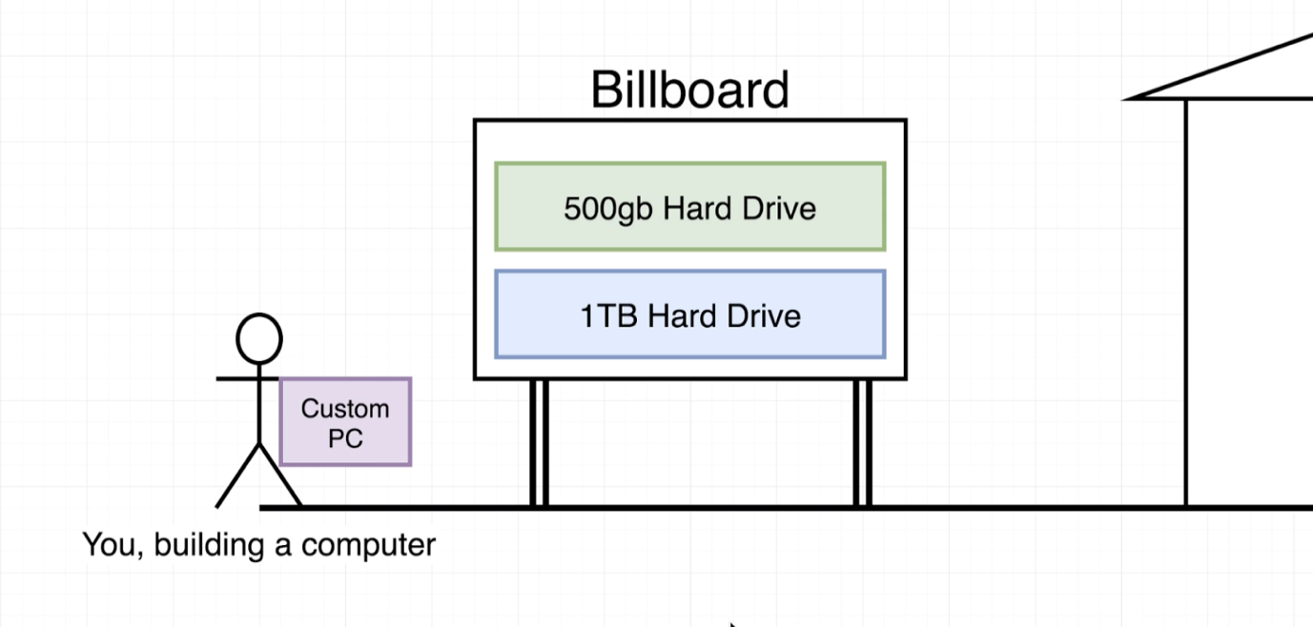

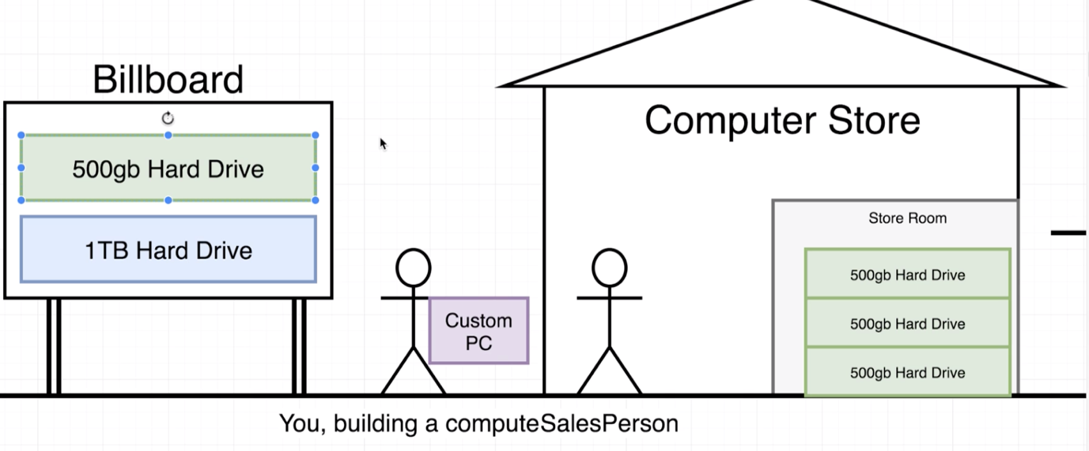

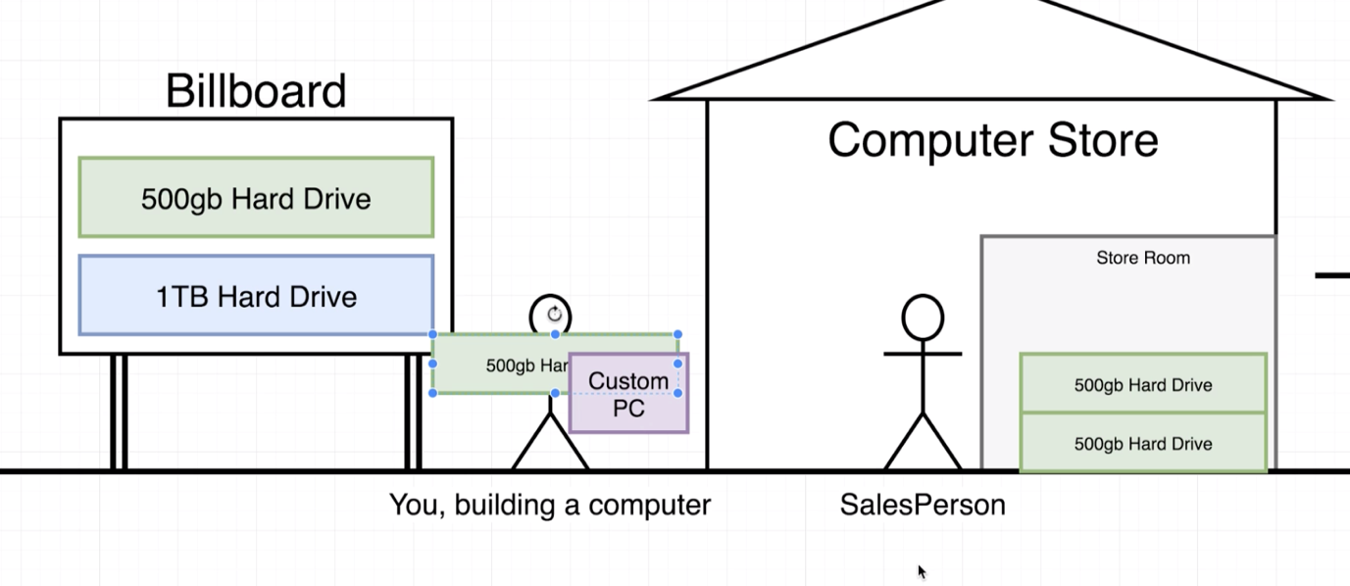

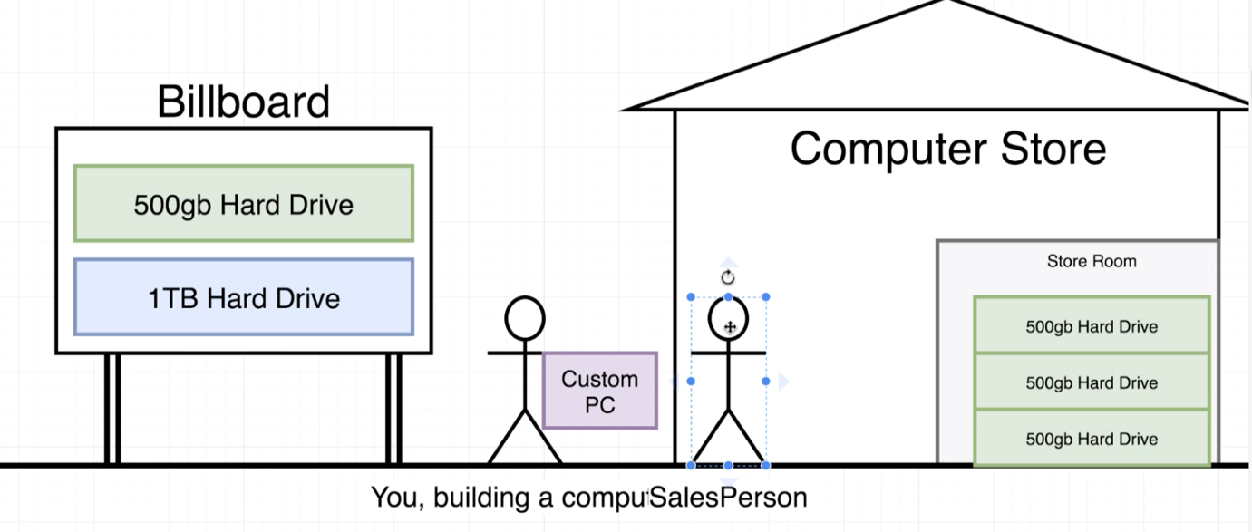

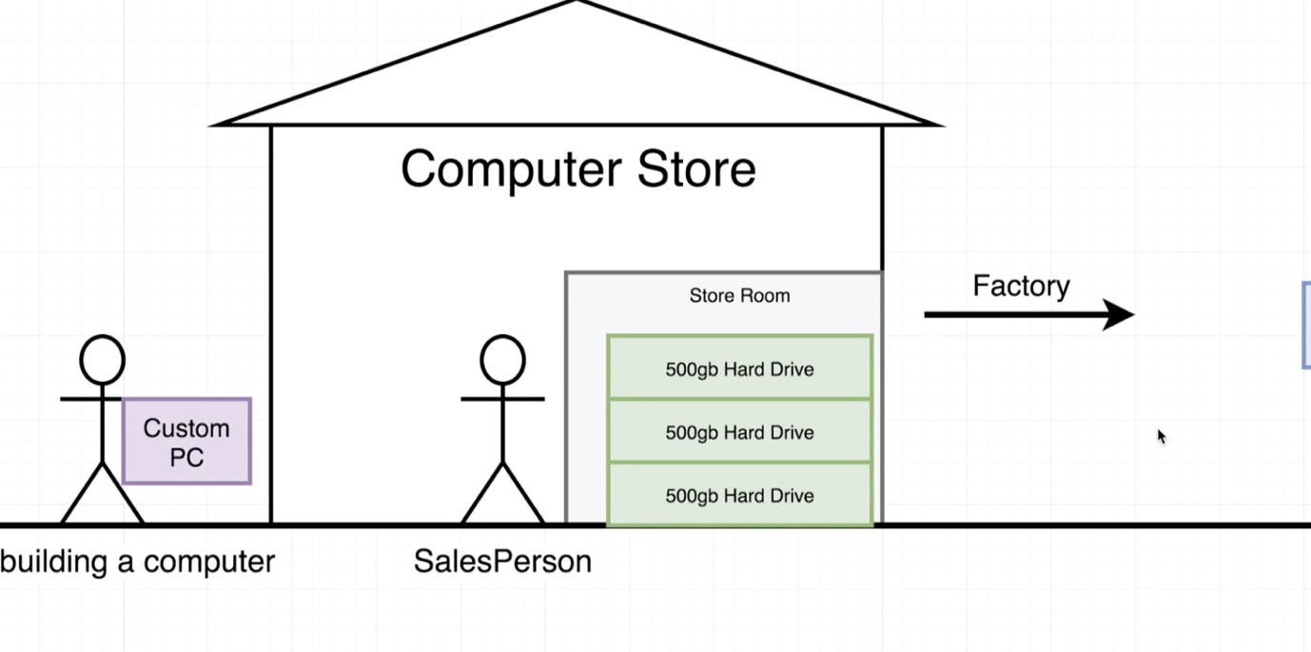

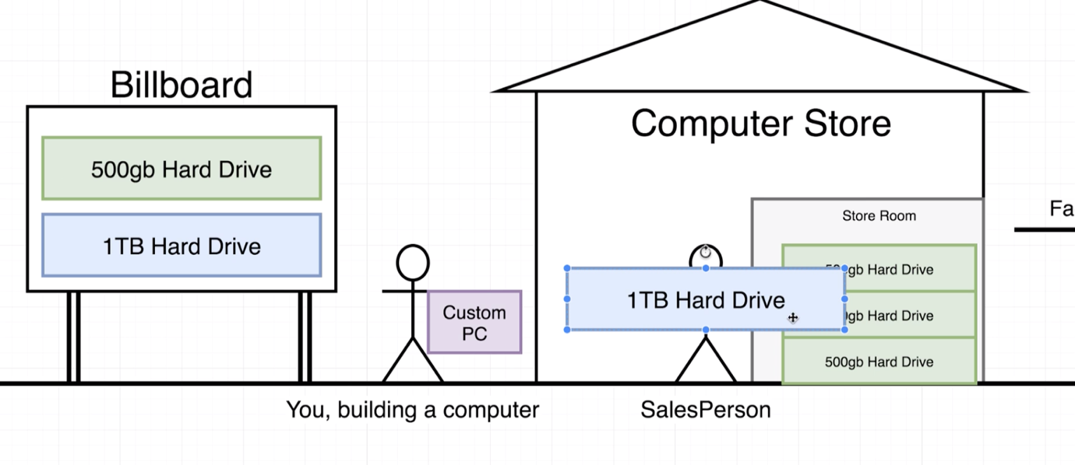

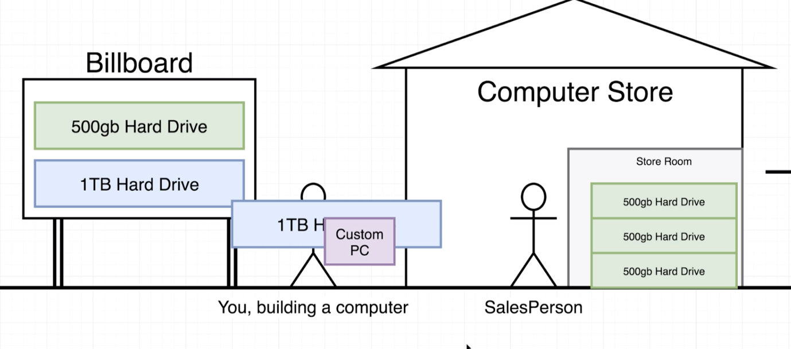

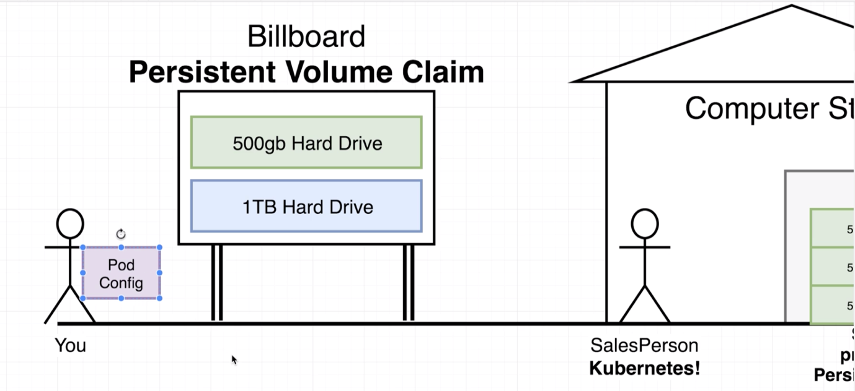

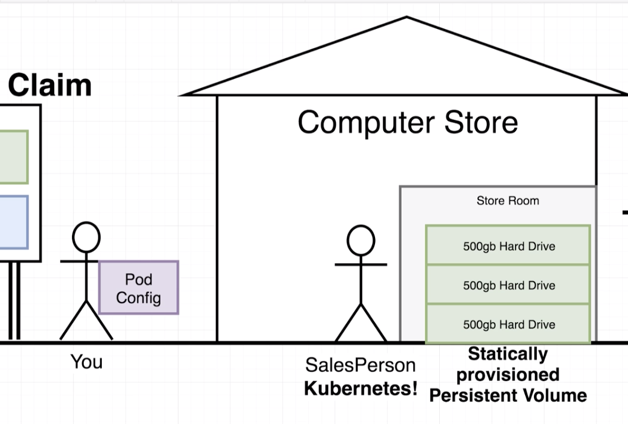

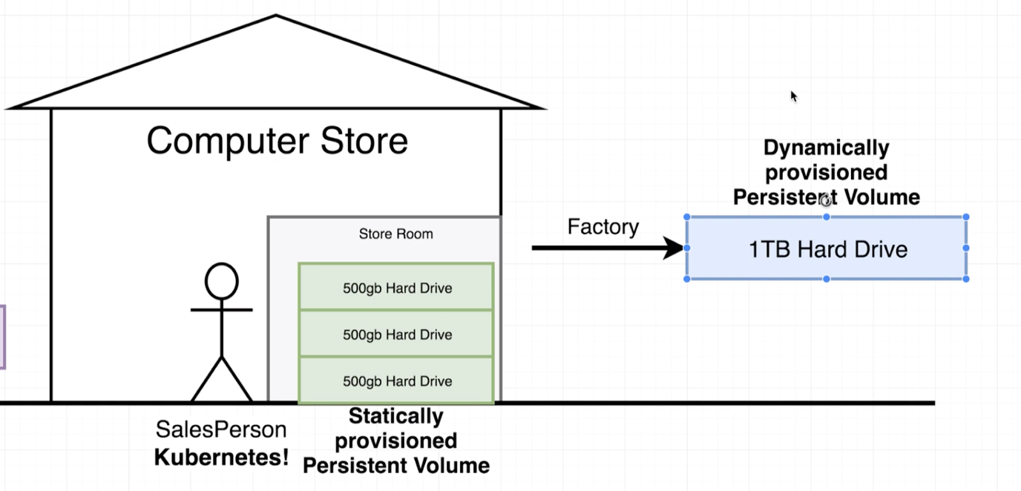

* **Claim Config Files:**

apiVersion: v1

kind: PeristentVolumeClaim

metadata:

name: database-persistent-volume-claim

spec:

accessModes:

- ReadWriteOnce

resources:

requests:

storage: 2Gi

* **Persistent Volume Access Modes**

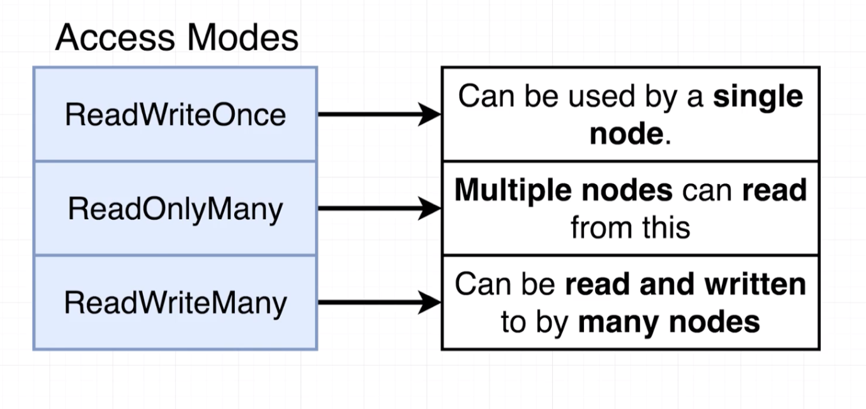

* **Where does Kubernetes Allocate Persistent Volumes?**

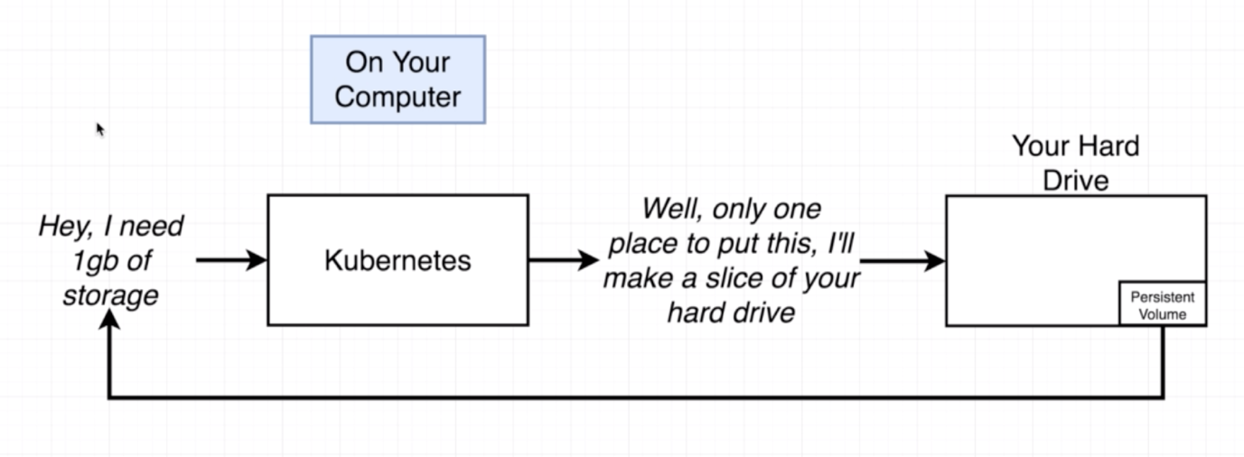

kubectl get storageclass



kubectl describe storageclass

Name: standard

IsDefaultClass: Yes

Annotations: kubectl.kubernetes.io/last-applied-configuration={"apiVersion":"storage.k8s.io/v1","kind":"StorageClass","metadata":{"annotations":{"storageclass.kubernetes.io/is-default-class":"true"},"labels":{"addonmanager.kubernetes.io/mode":"EnsureExists"},"name":"standard"},"provisioner":"k8s.io/minikube-hostpath"}

,storageclass.kubernetes.io/is-default-class=true

Provisioner: k8s.io/minikube-hostpath

Parameters: <none>

AllowVolumeExpansion: <unset>

MountOptions: <none>

ReclaimPolicy: Delete

VolumeBindingMode: Immediate

Events: <none>

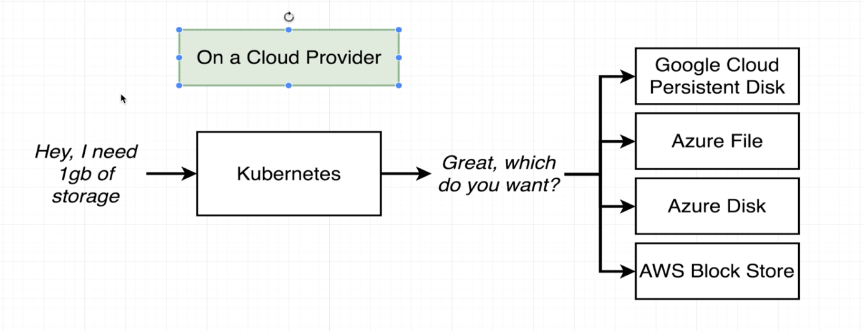

The default claim will work for local (minikube), but if we make use of any cloud provider the we have to specify the StorageClassName in the config file.

apiVersion: v1

kind: PeristentVolumeClaim

metadata:

name: database-persistent-volume-claim

spec:

accessModes:

- ReadWriteOnce

resources:

requests:

storage: 2Gi

storageClassName:

* **Designating a PVC in a Pod Template:**

apiVersion: apps/v1

kind: Deployment

metadata:

name: postgres-deployment

spec:

replicas: 1

selector:

matchLabels:

component: postgres

template:

metadata:

labels:

component: postgres

spec:

volumes:

- name: postgres-storage

persistentVolumeClaim:

claimName: database-persistent-volume-claim

containers:

- name: postgres

image: postgres

ports:

- containerPort: 5432

volumeMounts:

- name: postgres-storage

mountPath: /var/lib/postgresql/data

subPath: postgres

* **Applying PVC:**

Use below apply command to apply the configuration files we created so far.

kubectl apply -f k8s

Check the persistent volume created by below command

kubectl get pv



Check the persistent volume claim by below command

kubectl get pvc



* **Defining Environment Variables:**

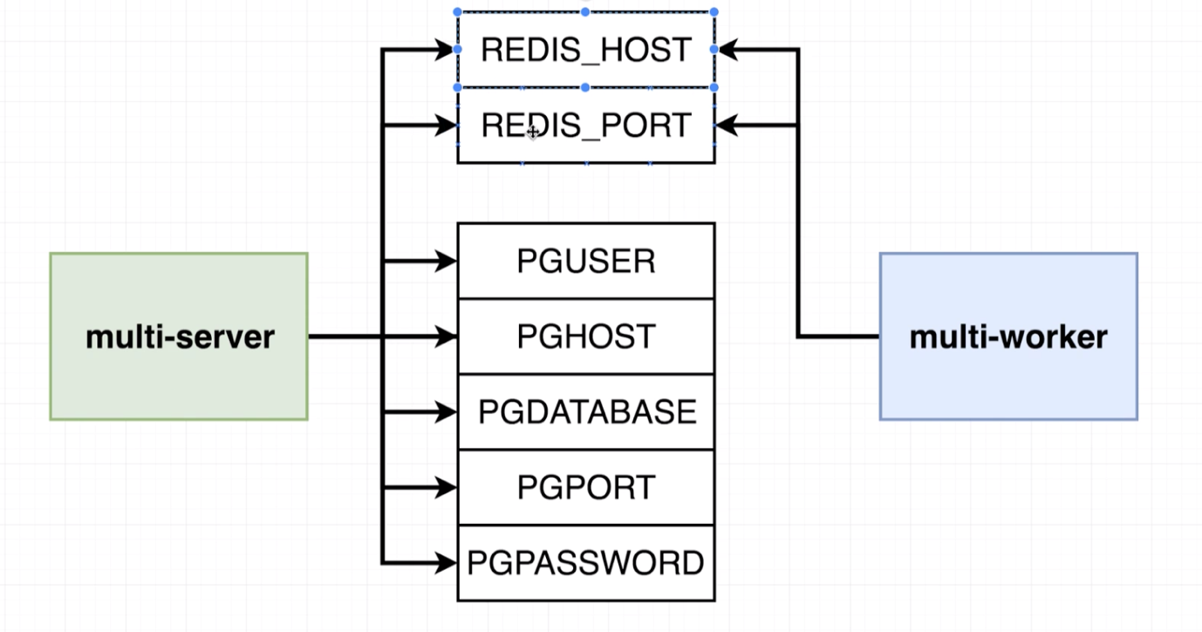

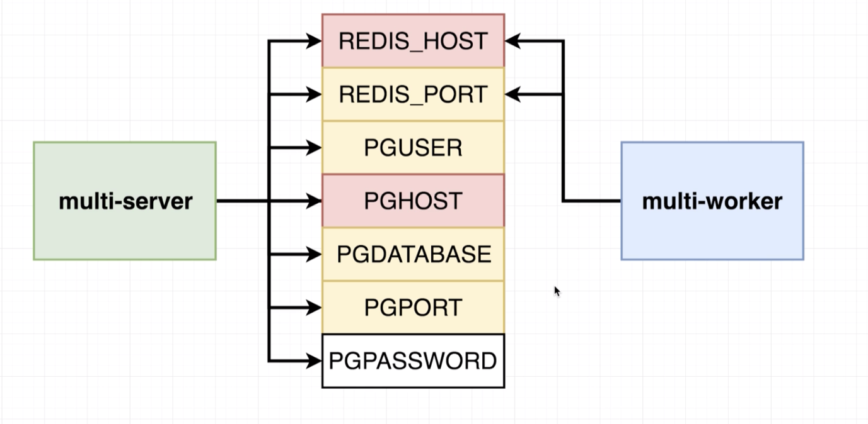

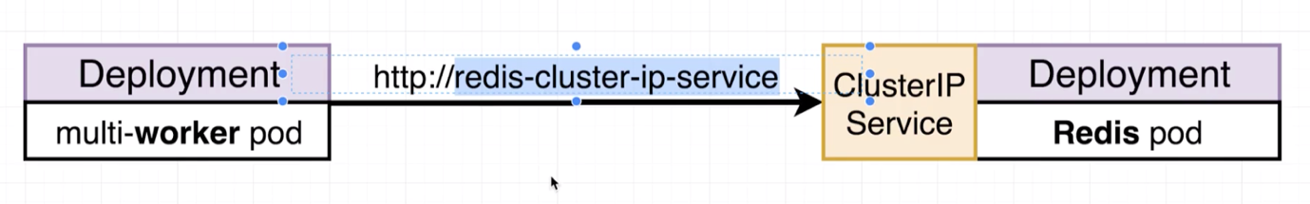

* **Adding Environment Variables to Config:**

apiVersion: apps/v1

kind: Deployment

metadata:

name: server-deployment

spec:

replicas: 3

selector:

matchLabels:

component: server

template:

metadata:

labels:

component: server

spec:

containers:

- name: server

image: stephengrider/multi-server

ports:

- containerPort: 5000

env:

- name: REDIS_HOST

value: redis-cluster-ip-service

- name: REDIS_PORT

value: 6379

- name: PGUSER

value: postgres

- name: PGHOST

value: postgres-cluster-ip-service

- name: PGPORT

value: 5432

- name: PGDATABASE

value: postgres

apiVersion: apps/v1

kind: Deployment

metadata:

name: worker-deployment

spec:

replicas: 1

selector:

matchLabels:

component: worker

template:

metadata:

labels:

component: worker

spec:

containers:

- name: worker

image: stephengrider/multi-worker

env:

- name: REDIS_HOST

value: redis-cluster-ip-service

- name: REDIS_PORT

value: 6379

* **Creating an Encoded Secret:**

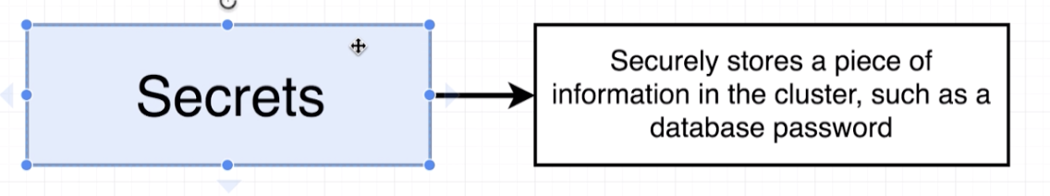

**Note:** With Secrets we have to run an imperative command.

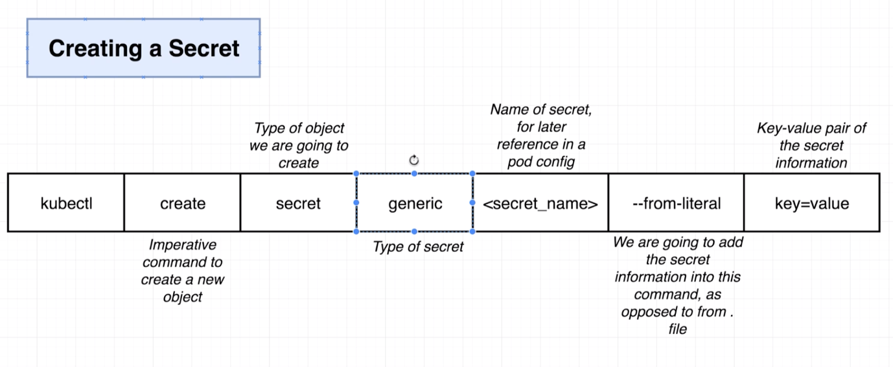

Types of secret:

Docker-registry

Tls

kubectl create secret generic pgpassword --from-literal PGPASSWORD=dspandiyan

secret/pgpassword created

kubectl get secrets



* **Passing Secrets as Environment Variables:**

apiVersion: apps/v1

kind: Deployment

metadata:

name: server-deployment

spec:

replicas: 3

selector:

matchLabels:

component: server

template:

metadata:

labels:

component: server

spec:

containers:

- name: server

image: stephengrider/multi-server

ports:

- containerPort: 5000

env:

- name: REDIS_HOST

value: redis-cluster-ip-service

- name: REDIS_PORT

value: 6379

- name: PGUSER

value: postgres

- name: PGHOST

value: postgres-cluster-ip-service

- name: PGPORT

value: 5432

- name: PGDATABASE

value: postgres

- name: PGPASSWORD

valueFrom:

secretKeyRef:

name: pgpassword

key: PGPASSWORD

apiVersion: apps/v1

kind: Deployment

metadata:

name: postgres-deployment

spec:

replicas: 1

selector:

matchLabels:

component: postgres

template:

metadata:

labels:

component: postgres

spec:

volumes:

- name: postgres-storage

persistentVolumeClaim:

claimName: database-persistent-volume-claim

containers:

- name: postgres

image: postgres

ports:

- containerPort: 5432

volumeMounts:

- name: postgres-storage

mountPath: /var/lib/postgresql/data

subPath: postgres

env:

- name: POSTGRES_PASSWORD

valueFrom:

secretKeyRef:

name: pgpassword

key: PGPASSWORD

* **Environment Variables as String:**

apiVersion: apps/v1

kind: Deployment

metadata:

name: worker-deployment

spec:

replicas: 1

selector:

matchLabels:

component: worker

template:

metadata:

labels:

component: worker

spec:

containers:

- name: worker

image: stephengrider/multi-worker

env:

- name: REDIS_HOST

value: redis-cluster-ip-service

- name: REDIS_PORT

value: '6379'

apiVersion: apps/v1

kind: Deployment

metadata:

name: server-deployment

spec:

replicas: 3

selector:

matchLabels:

component: server

template:

metadata:

labels:

component: server

spec:

containers:

- name: server

image: stephengrider/multi-server

ports:

- containerPort: 5000

env:

- name: REDIS_HOST

value: redis-cluster-ip-service

- name: REDIS_PORT

value: '6379'

- name: PGUSER

value: postgres

- name: PGHOST

value: postgres-cluster-ip-service

- name: PGPORT

value: '5432'

- name: PGDATABASE

value: postgres

- name: PGPASSWORD

valueFrom:

secretKeyRef:

name: pgpassword

key: PGPASSWORD